1D Rod with quenchers

10 nm diam. Particle with 9 quenchers w/ 4 nm quenching ( **NOT FORSTER)** radius (from data)

 = 1 nm



Assume rod volume = CPN volume





Rod length:



Rq = 4 nm, 

Rod quenching volume (assuming no overlap of quenching diameters):



Quenching volume is ~8% of total rod volume

2D sheet, L = 1 nm thick, Vsheet = VCPN with 9 quenchers





~86% of volume is quenched

Compare sphere of radius Rq to 1 nm diam. Rod of length 2*Rq





Vsphere/Vrod = 268 nm3/6.28 nm3 = 42.7



A hexagon can be broken down into 6 equilateral triangles, and given that 1 C-C bond in benzene is 0.140 nm (i.e. this equals one of the triangle’s sides), we can assume the widest part of each 6-membered ring in PFBT is ~2*0.140 nm = .240 nm. Assume all bonds between rings = 0.140 nm (probably not technically correct, but close enough), since it’s conjugated. Add one linker bond between the two repeat units that we are assuming one chromophore is made up of.

If we define the rod axis along the para-positioned sigma bonds between the monomer/copolymer units, then there are three 6-membered rings with one bond between each of them along the rod axis, per monomer unit. So 8 bond lengths per monomer, half-counting each end bond which adds up to 9 bond lengths per monomer, so the length of one chromophore L = (9*2)*0.140 nm = 18*0.140 nm = 2.52 nm/chromophore.

Number of chromophores per CPN

10,000 g/mol PFBT, 10 nm particle diameter, density = 1 g/cm3







Weight of one chromophore ~ 1044 g/mol

Roughly 10 chromophores per 10000 g/mol chain

Roughly 320 chromophores per 5 nm radius nanoparticle

1D Contour Length L = #Chromophores*length of one chromophore = 320 chromophores*2.52 nm/chromophore ~806 nm or 8.06e-5 cm.



From previous 1D calculation, 72 nm or 7.2e-6 cm of the contour length is quenched if 9 quenchers with a 4 nm quenching radius are assumed.



~9% of the contour length is quenched.

A mean value of 9 quenchers was calculated for a 5 nm radius particle of PFBT, which has 32 chains per particle. So, on average each particle has 9 quenchers per 32 chains equaling 0.281 quenchers/chain. If we assume poisson statistics, then some fraction of the 32 chains will have no quenchers, 1 quencher…etc. The probability given by a Poisson distribution of quenchers with a mean value of 9/32 (0.281) is given below:

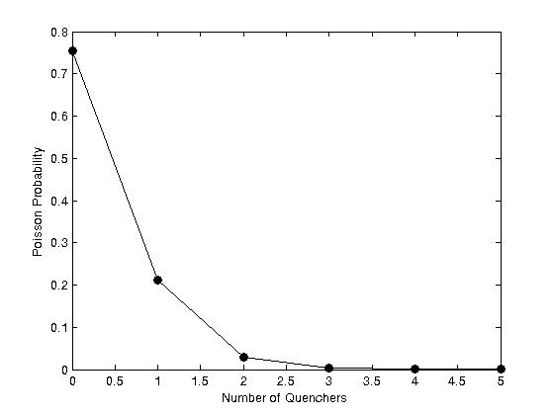

If we multiply these probabilities by the total number of chains in a CPN, we get the number of chains that contain 0, 1, 2…etc. quenchers:

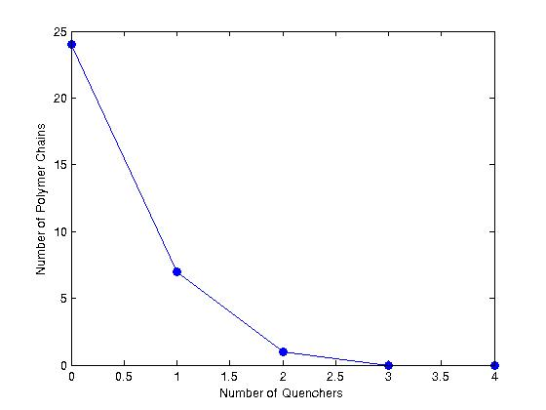

In this case, 24 chains have no quenchers, 7 chains have 1 quencher, and 1 chain has 2 quenchers, and we still recover our ~9% total quenched contour length. Broken down for each chain length, each chain is roughly 25.2 nm (806 nm/32 chains). The chains containing 1 quencher have 8 nm of their length quenched, which amounts to ~32% quenching. The chains containing 2 quenchers have 16 nm of their length quenched, which amounts to ~64% quenching.